# String Functions Assignment

**Q1.WAP to prompt and read a line of text with words separated by space. Tokenise and**

**extract the words. Display them. Impement the following functions for this.**

* 1. **int tokenise(char *arr); //tokenise and display tokens , return number of tokens to the caller**

**[Use strtok() to tokenise]**

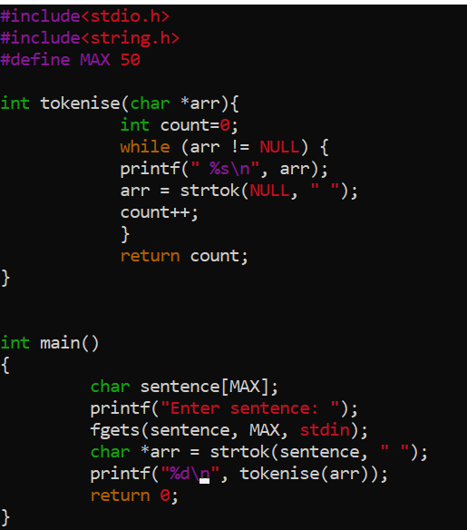

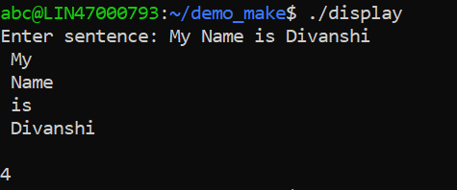

**Q2. Implement your own strncat() which shall concatenate n characters from src to dest. char *strncat(char *dest, const char *src, size_t n)**

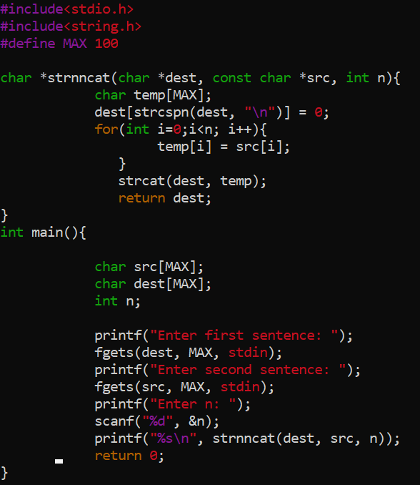

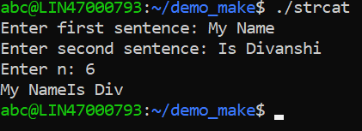

**Q3.WAP to**

* 1. **Search for and replace the vowel characters (upper and lower case) with “ay” in a word read from user. Consider a maximum word length of 40 characters.**
  2. **Identify the test inputs to be used**
  3. **Display updated string**

